WEEK 12
WEEK ENDING: |  | DAY: |  | Subject: R.M.E
Duration: |  |  |  | Strand: Religious Practices
Class: B7 |  | Class Size: |  | Sub Strand: Religious Songs and Recitations
Content Standard:  B7 2.2.1 Analyze and apply the moral values in religious songs and recitations |  |  | Indicator:  B7 2.2.1.2: Demonstrate understanding of basic scripture recitations/oral traditions in the Christian religions
Performance Indicator:  Learners can recite Christian religious passages or recitations |  |  |  | Core Competencies:  Communication and Collaboration, Critical Thinking and Problem solving
References: R.M.E Curriculum Pg.8
Phase/Duration | Learners Activities |  |  |  | Resources
PHASE 1: STARTER | Group learners according to the religion they belong.  Have each group sing songs and perform any act of worship of that religion.  Share performance indicators and introduce the lesson.
PHASE 2: NEW LEARNING | Show real or pictures of songs and recitations from the Bible.  Example: Psalm 23 (RSV), Exodus 20 (The Ten Commandments), etc  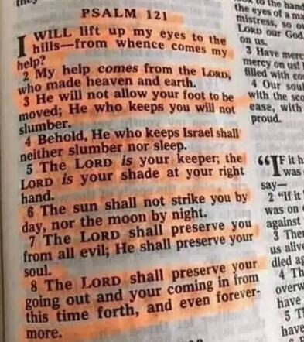  Call learners in turns to sing and recite texts from the Bible.  In groups learners tell the class some moral lessons from the Bible text. |  |  |  | Bible
PHASE 3: REFLECTION | Use peer discussion and effective questioning to find out from learners what they have learnt during the lesson.  Take feedback from learners and summarize the lesson.

WEEK ENDING: |  | DAY: |  | Subject: R.M.E
Duration: |  |  |  | Strand: Religious Practices
Class: B7 |  | Class Size: |  | Sub Strand: Religious Songs and Recitations
Content Standard:  B7 2.2.1 Analyze and apply the moral values in religious songs and recitations |  |  | Indicator:  B7 2.2.1.2: Demonstrate understanding of basic scripture recitations/oral traditions in the Islamic religions
Performance Indicator:  Learners can recite Islamic religious passages or recitations |  |  |  | Core Competencies:  PL 6.4: CI 6.1: CP 5.1: CP 6.4: CP 5.6:
References: R.M.E Curriculum Pg.8
Phase/Duration | Learners Activities |  |  |  | Resources
PHASE 1: STARTER | Group learners according to the religion they belong.  Have each group sing songs and perform any act of worship of that religion.  Share performance indicators and introduce the lesson.
PHASE 2: NEW LEARNING | Show real or pictures of songs and recitations from the Quran.  Example: Al- Fatihah (Qur’an chapter 1), Al-Ikhlas (Qur’an Chapter 112), etc. 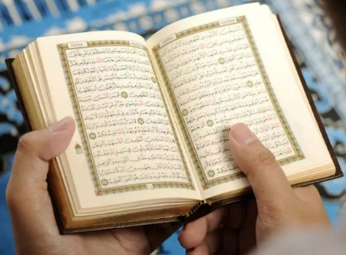  Call learners in turns to sing and recite texts from the Quran.  In groups learners tell the class some moral lessons from the Quran text. |  |  |  | Quran
PHASE 3: REFLECTION | Use peer discussion and effective questioning to find out from learners what they have learnt during the lesson.  Take feedback from learners and summarize the lesson.

WEEK ENDING: |  | DAY: |  | Subject: R.M.E
Duration: |  |  |  | Strand: Religious Practices
Class: B7 |  | Class Size: |  | Sub Strand: Religious Songs and Recitations
Content Standard:  B7 2.2.1 Analyze and apply the moral values in religious songs and recitations |  |  | Indicator:  B7 2.2.1.2: Demonstrate understanding of basic scripture recitations/oral traditions in the Islamic religions
Performance Indicator:  Learners can recite traditional religious passages or recitations |  |  |  |  | Core Competencies:  Communication and Collaboration, Critical Thinking and Problem solving
References: R.M.E Curriculum Pg. 8
Phase/Duration | Learners Activities |  |  |  |  | Resources
PHASE 1: STARTER | Group learners according to the religion they belong.  Have each group sing songs and perform any act of worship of that religion.  Share performance indicators and introduce the lesson.
PHASE 2: NEW LEARNING | Show real or pictures of songs and recitations from any recital from the traditional religion-sacred myths, riddle, proverbs, etc. (Traditional).  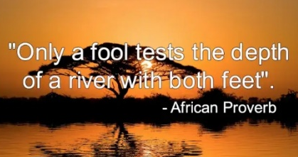  “a rolling stone gathers no moss”  Call learners in turns to sing and recite Traditional myths, riddle or proverbs.  In groups, learners tell the class some moral lessons from the myths, riddle or proverbs |  |  |  |  | Wall charts, wall words, posters, video clip, etc.
PHASE 3: REFLECTION | Use peer discussion and effective questioning to find out from learners what they have learnt during the lesson.  Take feedback from learners and summarize the lesson.

